

|  |
| --- |
| FusionInvest |
| Mediolanum inbound RBC CSV files |
| Equities, fixed income, loans, forex, options, futures, cash transfers and invoices |

|  |
| --- |
| Cristian Berceanu  12 September 2016 |



Contents

Toolkit behaviour and custom parameters 2

Rich Market Adapter configuration 8

Adding toolkit custom parameters 10

**© Misys Limited   
All rights reserved**

**Registered in   
England & Wales**

No. 01360027

**Registered Office:**One Kingdom Street Paddington   
London W2 6BL  
United Kingdom

Toolkit behaviour and custom parameters

The purpose of this toolkit is to select the portfolio where a trade will be booked based on the **CommonIdentifier** field in the received CSV file and to select the broker of a trade based on the **DelegateManagerID**. The **CommonIdentifier** is a concatenation of the RBC Fund Identifier and the RBC Delegate Manager Identifier.

For example: DB4223**Z**9173803

* DB4223 - Challenge International Equity Fund
* 9173803 - The Delegate Manager

The CommonIdentifier is the account at custodian defined in FusionInvest for accounts at Back Office -> Nostro Management -> Accounts.

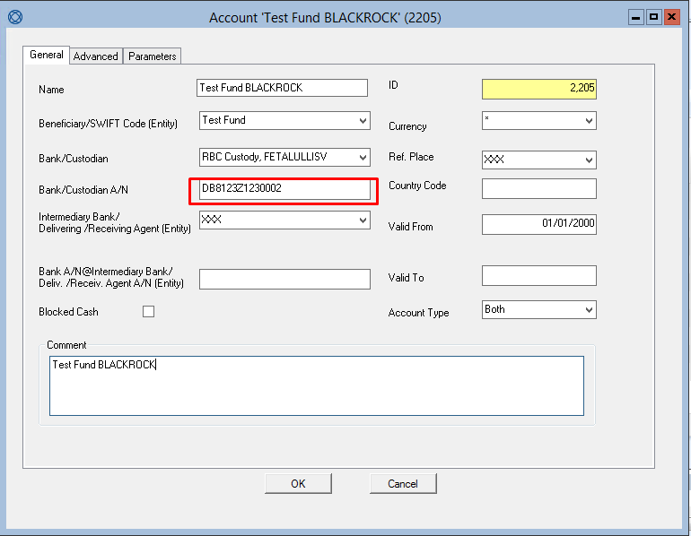

The **RootPortfolio** and **DelegateManagerID** are defined as external references for accounts.

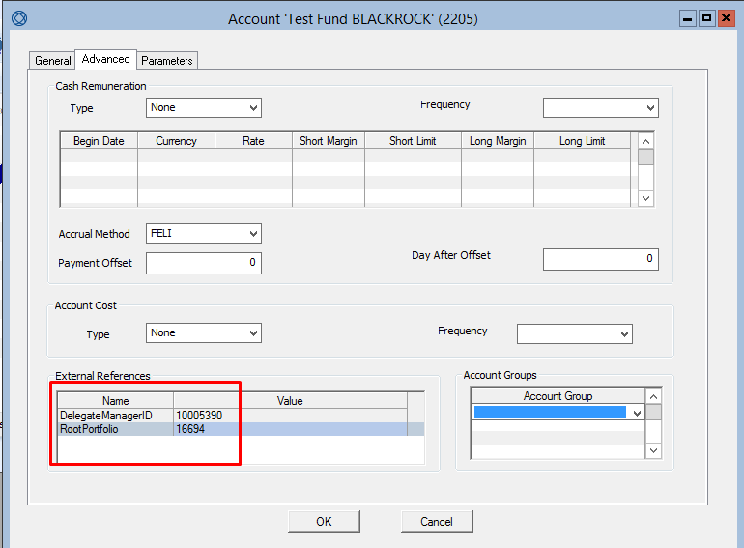

The **RootPortfolio** is the folio id where the trades will be booked by default.

The CSV columns mapped to fields in FusionInvest are shown in Tables 1 - 6.

There are 13 customizable parameters for this toolkit:

1. **UseStrategyFolios** (default value: false) : If this parameter is false, the toolkit will place the trade in **RootPortfolio** and if this parameter is true, the toolkit will place the trade in the strategy subfolio (“EQUITIES”, “BONDS”, etc.) of the **RootPortfolio**.

For example: Blackrock is the RootPortfolio and the strategy subfolio is EQUITIES.

1. **ValidateGrossAmount** (default value: false) : If this parameter is false, no additional validation will be done, otherwise the toolkit will check if the value of the gross amount in received CSV file is close to a calculated value of gross amount using the following condition:

If this condition is false, the trade will not be imported and an error message will be written to RMA log file.

1. **GrossAmountEpsilon** (default value: 0.1) : The value of GrossAmountEpsilon.
2. **ValidateNetAmount** (default value: false) : If this parameter is false, no additional validation will be done, otherwise the toolkit will check if the value of the net amount in received CSV file is close to a calculated value of gross amount using the following condition:

If this condition is false, the trade will not be imported and an error message will be written to RMA log file.

1. **NetAmountEpsilon** (default value: 0.1) : The value of NetAmountEpsilon.
2. **ValidateForexAmount** (default value: true) : If this parameter is false, no additional validation will be done, otherwise the toolkit will check if the value of the sold amount in received CSV file is close to a calculated value of sold amount using the following condition:

If this condition is false, the trade will not be imported and an error message will be written to RMA log file.

1. **ForexAmountEpsilon** (default value: 0.01) : The value of ForexAmountEpsilon.
2. **DefaultCounterparty** : Name of the default counterparty for inbound trades.
3. **UseDefaultCounterparty** : DefaultCounterparty applies for all inbound trades when this parameter is **true**.
4. **DefaultDepositary** : Name of the default depositary for inbound trades
5. **UseDefaultDepositary** : DefaultDepositary applies for all inbound trades when this parameter is **true**.
6. **ReplaceBORemarks** : BORemarks field for imported trades will be replaced by Transaction ID if this parameter is **true.**
7. **MAMLZCodes** : List of MAML Z Codes in CSV format (see Table 4); If the **CommonIdentifier** of the inbound file contains one of the MAML Z Codes, the broker for the trade is selected by **BIC Code (SWIFT)** insetead of **DelegateManagerID**.

The amounts are calculated using the following formulas:

Table 1: Equities, bonds and loans mapped fields

|  |  |  |  |
| --- | --- | --- | --- |
| Column Index | Column Name | Mapped field | Comment |
| 1 | Fund Custody Code | Not used | Not used |
| 2 | External Fund Identifier | Account at custodian | CommonIdentifier |
| 3 | Fund Name | Not used | Not used |
| 4 | Trade Date | Trade date | format = ddMMyyy |
| 5 | Settlement Date | Settlement Date | format = ddMMyyy |
| 6 | Transaction ID | FO Remarks |  |
| 7 | Fund Manager Reference | Not used | Not used |
| 8 | Transaction Type | Not used | Not used |
| 9 | Transaction Description | Side (Buy or Sell) | "SECURITIES PURCHASE" or "SECURITIES SELL" (for shares and bonds) and "SECURITIES DIRECT ENTRY" or "SECURITIES WITHDRAWAL" (for loans) |
| 10 | Reversal Flag | Not used | Not used |
| 11 | Security Name | Not used | Not used |
| 12 | Broker Name | Not used | Not used |
| 13 | ISIN Code | ISIN Code |  |
| 14 | Security Description | Instrument type | "EQUITIES" for shares, "BONDS" for bonds, "MEMMM" for loans |
| 15 | Quantity | Quantity | Trade amount |
| 16 | Currency | Settlement currency |  |
| 17 | Price | Spot price |  |
| 18 | Gross Amount | Not imported | Gross amount is calculated, validation is optional |
| 19 | Brokerage | Broker fees |  |
| 20 | Tax | Market fees |  |
| 21 | Expenses | Counterparty fees |  |
| 22 | Net Amount | Not imported | Net amount is calculated, validation is optional |
| 23 | Broker BIC Code | Not used | Not used |
| 24 | Fund Manager BIC Code | Not used | Not used |
| 25 | Bloomberg Code | Bloomberg code |  |

Table 2: Forex mapped fields

|  |  |  |  |
| --- | --- | --- | --- |
| Column Index | Column name | Mapped field | Comment |
| 1 | Fund Custody Code | Not used | Not used |
| 2 | External Fund Identifier | Account at custodian | CommonIdentifier |
| 3 | Fund Name | Not used | Not used |
| 4 | Trade Date | Trade date | format = ddMMyyy |
| 5 | Value Date | Value Date | format = ddMMyyy |
| 6 | Transaction ID | FO Remarks |  |
| 7 | Reversal Flag | Not used | Not used |
| 8 | Buy Currency | FX rate way (CCY2) | CCY1/CCY2 |
| 9 | Purchased Amount | Quantity |  |
| 10 | Sell Currency | FX rate way (CCY1) | CCY1/CCY2 |
| 11 | Sold Amount | Not imported | Optional validation |
| 12 | FX Rate | Price |  |
| 13 | Broker BIC Code | Not used | Not used |
| 14 | Broker Name | Not used | Not used |
| 15 | Fund Manager BIC Code | Not used | Not used |
| 16 | NDF Flag | NDF |  |

Table 3: Options mapped fields

|  |  |  |  |
| --- | --- | --- | --- |
| Column Index | Column name | Mapped field | Comment |
| 1 | Consolidated Fund Code | Not used | Not used |
| 2 | Fund Code | Not used | Not used |
| 3 | External Fund Identifier | Account at custodian | CommonIdentifier |
| 4 | Fund Name | Not used | Not used |
| 5 | Fund Ccy | Not used | Not used |
| 6 | Manager Code | Not used | Not used |
| 7 | Counterparty/Broker Code | Not used | Not used |
| 8 | Counterparty/Broker Description | Not used | Not used |
| 9 | GTI Code | Not used | Not used |
| 10 | GTI Description | Not used | Not used |
| 11 | Option Type | Option Type | CALL or PUT |
| 12 | Option description | Not used | Not used |
| 13 | Option RBCDIS Code | Not used | Not used |
| 14 | Option Currency | Settlement currency |  |
| 15 | Option Strike | Option strike |  |
| 16 | Contract Size | Not used | Not used |
| 17 | Contract Number | Not used | Not used |
| 18 | Trade Date | Trade date | format = ddMMyyy |
| 19 | NAV Date | Payment Date | format = ddMMyyy |
| 20 | Transaction Value Date | Settlement Date | format = ddMMyyy |
| 21 | Quantity | Quantity |  |
| 22 | Premium | Price |  |
| 23 | Trade Amount | Not used | Not used |
| 24 | Commission Amount | Broker fees |  |
| 25 | Fees Amount in Transaction Currency | Not used | Not used |
| 26 | Transaction Status Code | Not used | Not used |
| 27 | Transaction Code | Not used | Not used |
| 28 | Contract Status | Not used | Not used |
| 29 | Broker Code | Not used | Not used |
| 30 | Broker Name | FO remarks |  |
| 31 | Style | Option style | American, European or Bermuda |
| 32 | Bloomberg Code | Bloomberg Code |  |
| 33 | Fusion Ref. | Not used | Not used |
| 34 | Underlying Asset | Not used | Not used |
| 35 | BIC Code | Not used | Not used |
| 36 | Buy/Sell | Side |  |
| 37 | Fund Manager BIC Code | Not used | Not used |

Table : Futures mapped fields

|  |  |  |  |
| --- | --- | --- | --- |
| Column Index | Column name | Mapped field | Comment |
| 1 | Consolidated Fund Code | Not used | Not used |
| 2 | Fund Code | Not used | Not used |
| 3 | External Fund Identifier | Account at custodian | CommonIdentifier |
| 4 | Fund Name | Not used | Not used |
| 5 | Fund Currency | Not used | Not used |
| 6 | Manager Code | Not used | Not used |
| 7 | Counterparty/Broker Code | Not used | Not used |
| 8 | Counterparty/Broker Description | FO remarks |  |
| 9 | GTI Code | Not used | Not used |
| 10 | GTI Description | Not used | Not used |
| 11 | Future RBCDIS Code | Not used | Not used |
| 12 | Underlying ISIN | Not used | Not used |
| 13 | Future Description | Not used | Not used |
| 14 | Future Maturity Date | Not used | Not used |
| 15 | Future Currency | Currency |  |
| 16 | Contract Number | Not used | Not used |
| 17 | Trade Date | Trade date | format = ddMMyyy |
| 18 | Accounting Date | Payment Date | format = ddMMyyy |
| 19 | Transaction Value Date | Settlement Date | format = ddMMyyy |
| 20 | Trade Description | Not used | Not used |
| 21 | Quantity | Quantity |  |
| 22 | Trade Price | Price |  |
| 23 | Contract Size | Not used | Not used |
| 24 | Trade Amount | Not used | Not used |
| 25 | Commission Amount | Not used | Not used |
| 26 | Fees Amount in Transaction Currency | Not used | Not used |
| 27 | Transaction Code | Not used | Not used |
| 28 | Transaction Status Code | Not used | Not used |
| 29 | Contract Status | Not used | Not used |
| 30 | Future Trade Code | Not used | Not used |
| 31 | Bloomberg Code | Bloomberg Code |  |
| 32 | Underlying Asset | Not used | Not used |
| 33 | BIC Code | Not used | Not used |
| 34 | Buy/Sell | Side |  |

Table 5: Cash transfer mapped fields

|  |  |  |  |
| --- | --- | --- | --- |
| Column Index | Column name | Mapped field | Comment |
| 1 | Fund Custody Code | Not used | Not used |
| 2 | External Fund Identifier | Account at custodian | CommonIdentifier |
| 3 | Fund Name | Not used | Not used |
| 4 | Trade Date | Trade date | format = ddMMyyy |
| 5 | Value Date | Settlement Date | format = ddMMyyy |
| 6 | IBAN | FO remarks |  |
| 7 | Account Type | Not used | Not used |
| 8 | Currency | Settlement currency |  |
| 9 | Amount | Quantity | Price = 1 |
| 10 | Reversal Flag | Not used | Not used |
| 11 | Transaction Type | Not used | Not used |
| 12 | Transaction ID | Not used | Not used |

Table 6: Invoice mapped fields

|  |  |  |  |
| --- | --- | --- | --- |
| Column Index | Column name | Mapped field | Comment |
| 1 | Fund Custody Code | Not used | Not used |
| 2 | External Fund Identifier | Account at custodian | CommonIdentifier |
| 3 | Fund Name | Not used | Not used |
| 4 | Trade Date | Trade date | format = ddMMyyy |
| 5 | Value Date | Settlement Date | format = ddMMyyy |
| 6 | Fee Type | FO remarks |  |
| 7 | Currency | Settlement currency |  |
| 8 | Fee Amount | Quantity | Price = 1 |
| 9 | Transaction ID | Not used | Not used |
| 10 | Reversal Flag | Not used | Not used |

Rich Market Adapter configuration

1. Copy Mediolanum_RMA_FILTER.dll file to RichMarketAdapter\RichMarketAdapter\bin folder
2. Copy RichMarketAdapter\RichMarketAdapter\config\sample\SophisCsv.config to RichMarketAdapter\RichMarketAdapter\config folder if it does not already exist
3. Copy and overwrite **fieldconfig.xml** file in **RichMarketAdapter\RichMarketAdapter\data\csv** folder with **fieldconfig.xml** file provided in the delivery archive
4. Open Configuration Manager (tools/ RunConfigurationManager.bat)
5. Select SophisCsv.config
6. Set “xml” in RichMarketAdapter -> Core -> Technical -> Communicator

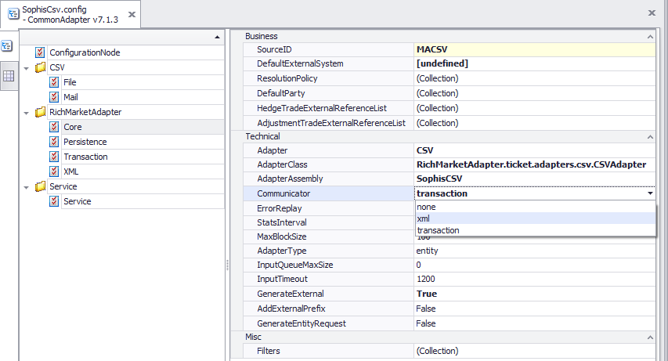

1. Add a new entry to RichMarketAdapter -> Core -> Misc -> Filters collection:

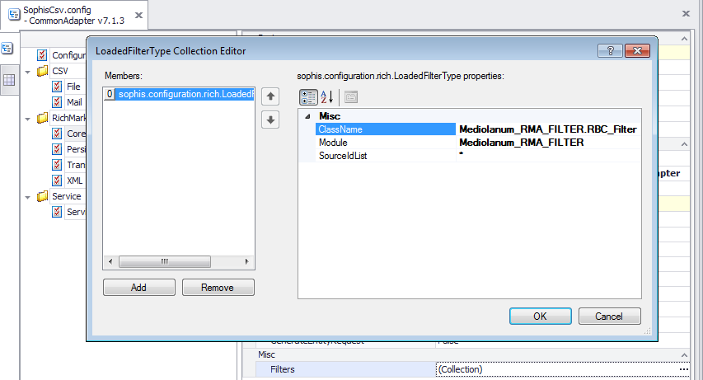

**ClassName:** Mediolanum_RMA_FILTER.RBC_Filter

**Module:** Mediolanum_RMA_FILTER

SourceIdList: *

1. In RichMarketAdapter -> XML:

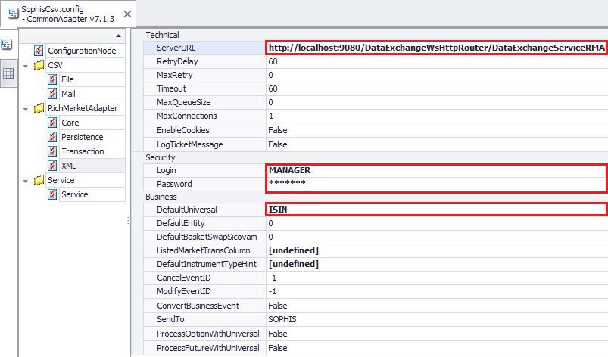

* Set Technical -> ServerURL:

http://[IS hostname and port]/DataExchangeWsHttpRouter/DataExchangeServiceRMA

* Set **Security -> Login and Password** with FusionInvest credentials
* Set **Business -> DefaultUniversal** with desired default universal reference (ISIN, BLOOMBERG, etc.)

Adding toolkit custom parameters

To add or modify a custom parameter (Table 3), Open Configuration Manager and select SophisCsv.config.



1. Click on “Add section”

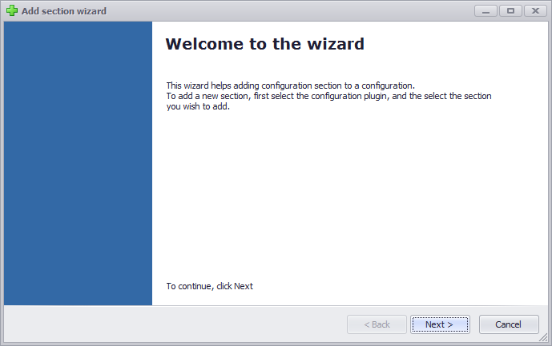

1. Click next
2. Select **APIConfiguration** and click next

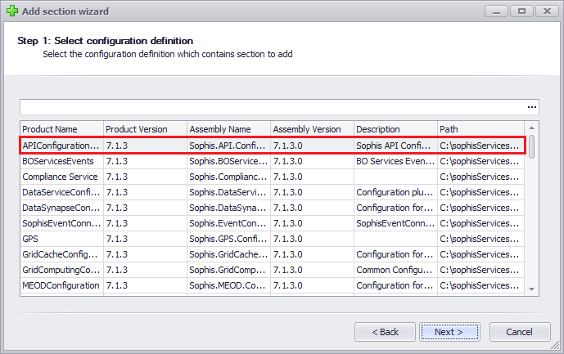

1. Check **APIConfiguration -> Toolkit** and click next

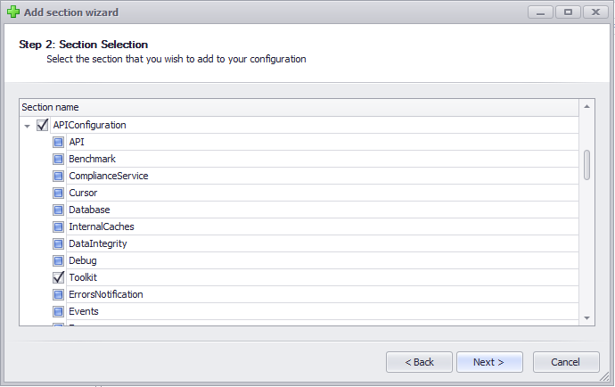

1. Click finish

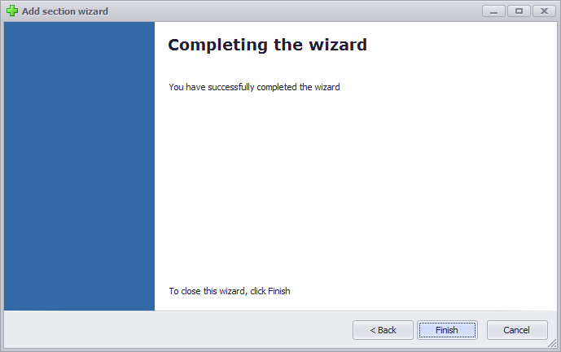

1. Select APIConfiguration->Toolkit->CustomParameters and add the desired parameters

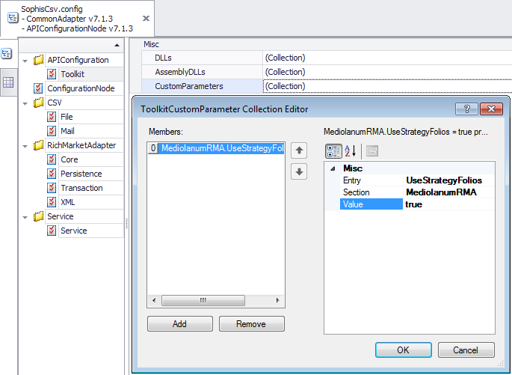

Table 7: Toolkit custom parameters

|  |  |  |
| --- | --- | --- |
| Entry | Section | Default value |
| UseStrategyFolios | MediolanumRMA | false |
| ValidateGrossAmount | MediolanumRMA | false |
| GrossAmountEpsilon | MediolanumRMA | 0.1 |
| ValidateNetAmount | MediolanumRMA | false |
| NetAmountEpsilon | MediolanumRMA | 0.1 |
| ValidateForexAmount | MediolanumRMA | true |
| ForexAmountEpsilon | MediolanumRMA | 0.01 |
| UseDefaultCounterparty | MediolanumRMA | true |
| DefaultCounterparty | MediolanumRMA | DELEGATE |
| UseDefaultDepositary | MediolanumRMA | true |
| DefaultDepositary | MediolanumRMA | RBC Custody |
| ReplaceBORemarks | MediolanumRMA | false |
| MAMLZCodes | MediolanumRMA | Z8719429;Z8730529;Z8730528;Z8894216;Z8730525;Z5950209;Z8894216;Z8730525;Z5950209;Z5950206;Z5950206 |

